
orksheet 7 Extra writing

- Write the words.
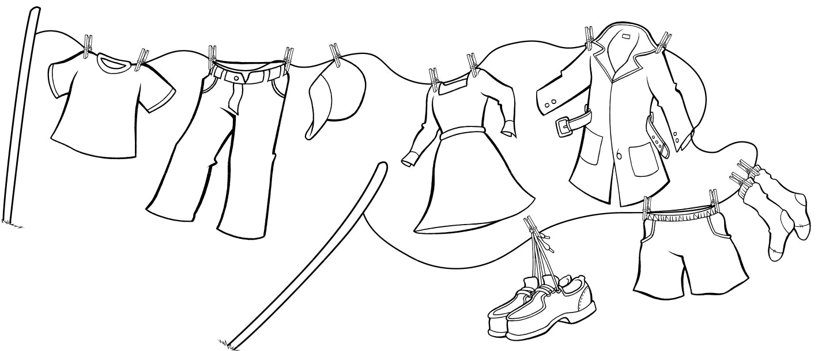

 |  | ^{s} h t |  |  |  |  | h |  |  |  |  |  | a _{o} |  | 5
 |  | ^{s} h t |  |  | s | a _{t} |  |  |  |  |  |  | a _{o} |  | 5
 | i | r |  | p | s | 3 |  |  |  |  |  |  | t _{c}
 | i | - ^{T} |  | p |  |  |  |  | e |  |  |  | t _{c}
 |  | 1 | n |  | t |  | d |  | e | s |  |  |  |  |  |  |  | o
 |  |  | a |  |  |  |  |  | s | r |  |  |  |  |  |  |  | o
 |  |  |  |  |  |  |  |  | s | r |  |  |  |  |  |  |  | c _{s} k
 |  |  | 2 |  |  | 4 |  |  |  |  |  |  |  | r | t | s |  | s
 |  |  |  |  |  |  |  |  |  |  |  |  |  | r | o | s ^{h} |  | 6
 |  |  |  |  |  |  |  |  |  |  |  | h o |  |  | o |  |  | 6
 |  |  |  |  |  |  |  |  | 8 | s | e ^{s} |  |  |  |  | 7
1 T-shirt |  |  |  |  |  | 2 |  |  |  |  |  | 3
4 |  |  |  |  |  | 5 |  |  |  |  |  | 6
7 |  |  |  |  |  | 8


- Look at the white clothes. Write. Then color.
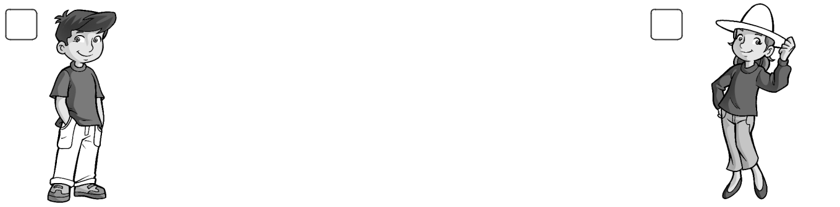

1 2

1 His pants are blue.

 | 2 | is pink.
3 | 3 | are red. | 4
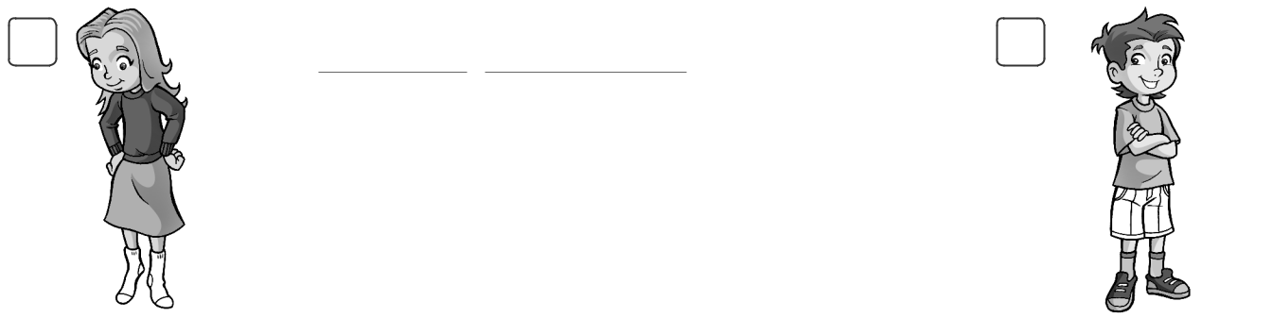

4 are yellow.


Family and Friends Special Edition Grade 3 | 50 | © Oxford University Press
Assessment and Resource Portfolio Unit 7 | 50 | Permission granted to reproduce for instructional use.


_{Worksheet} 7 Values

Warm clothes and cool clothes

- Draw.
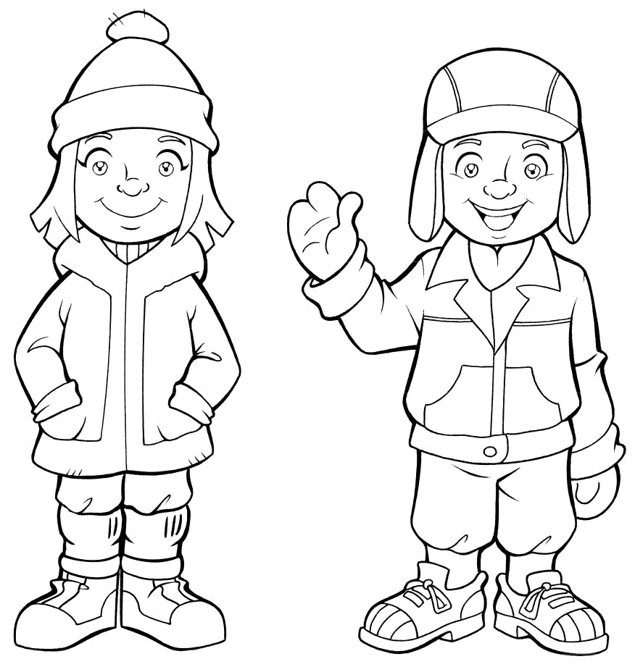
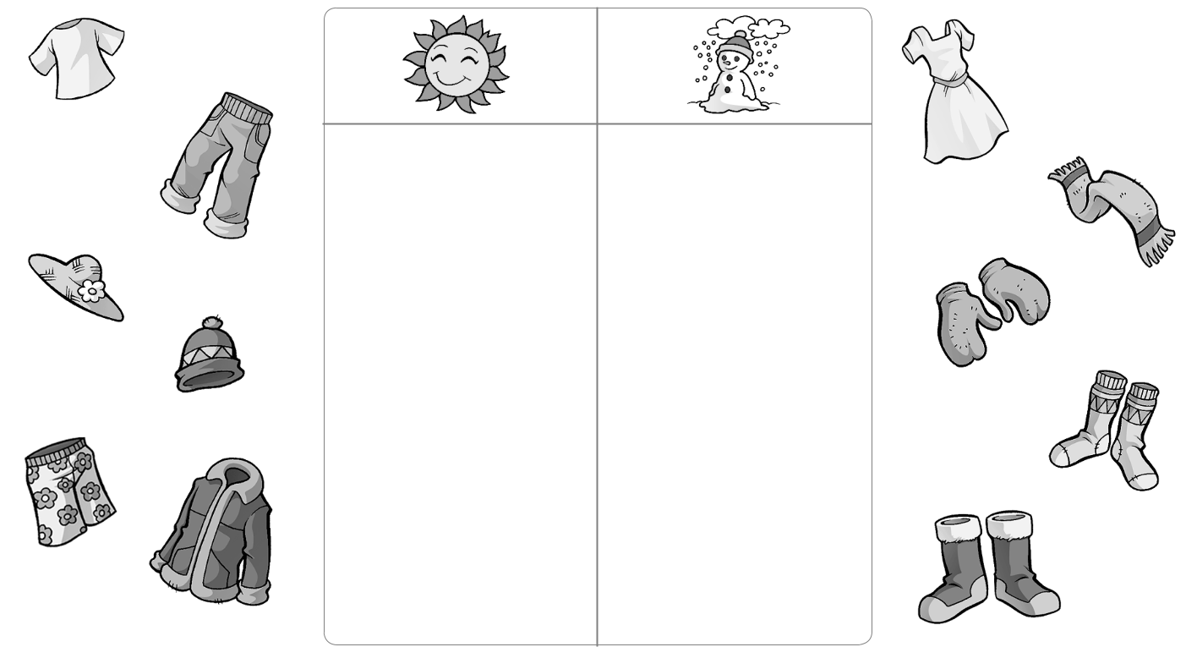

- Read and color.

Her coat is red.

His pants are blue.

Her hat is pink.

Her pants are yellow.

His socks are green.

His hat is orange.

Her socks are pink.

Family and Friends Special Edition Grade 3 | 51 | © Oxford University Press
Assessment and Resource Portfolio Unit 7 | 51 | Permission granted to reproduce for instructional use.


Test 7 Unit test

1 | Complete the words. |  |  | / 4
1 | 2 | 3 | 4 | 5
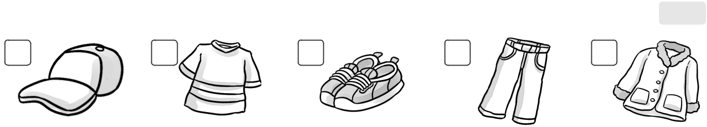

h a t |  |  | T- s i t |  |  |  |  | s |  | o s |  |  | p |  |  |  | ts | c |  |  |  | t
2 Circle the odd-one-out. Write. |  |  |  |  |  |  |  |  |  |  |  |  |  |  |  |  |  |  | / 3
1 |  |  | 2 |  |  |  |  |  |  | 3 |  |  |  |  |  |  |  | 4
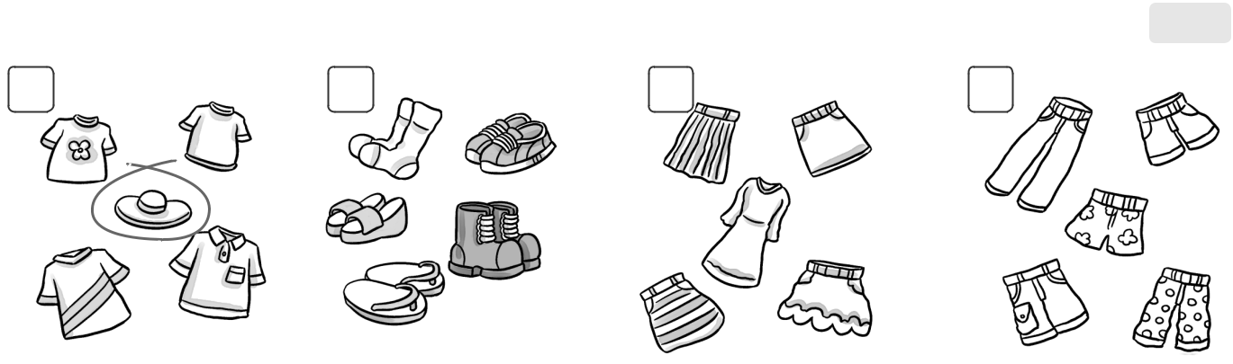

hat

3 Complete the sentences with his or her. |  |  |  | / 3
1 These are her shoes. |  |  | 2 This is |  | hat.
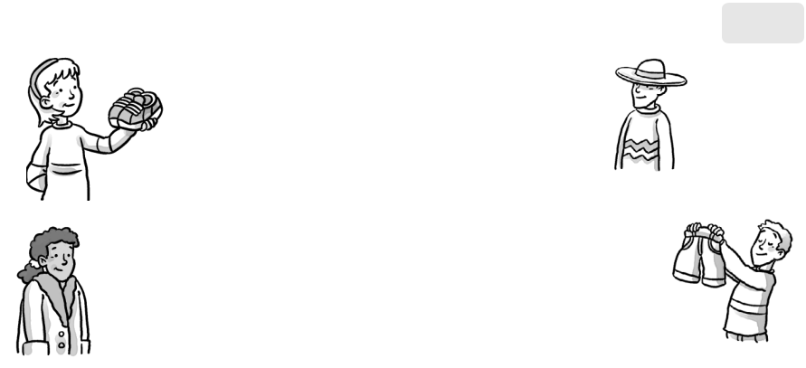

3 This is coat. 4 These are shorts.

4 Order the words. | / 5
1 these Are his shoes? | Are these his shoes?




2 they Yes, are.


3 her Are socks? these


4 this Is hat? her


5 aren’t. No, they


6 coat? Is this his

/15

Family and Friends Special Edition Grade 3 | 52 | © Oxford University Press
Assessment and Resource Portfolio Unit 7 | 52 | Permission granted to reproduce for instructional use.

