
TOEFL 8 Reading
Primary

- Look at the picture. Circle A, B, or C.


Example (A) This is the bedroom.
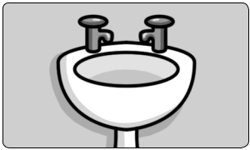


  - This is the bathroom.

  - This is the dining room.

- (A) It’s in the living room.

  - It’s in the dining room.

  - It’s in the kitchen.

- (A) The bedroom is upstairs.

  - The bedroom is downstairs.

  - The kitchen is downstairs.

- Are Lan and Huy in the living room?

  - Yes, they are.

  - No, they aren’t.

  - No, she isn’t.

- Where do you live?

  - I live in a house.

  - There are six bedrooms in my house.

  - I live in an apartment.

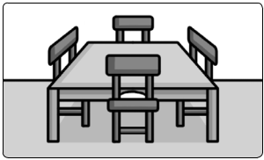
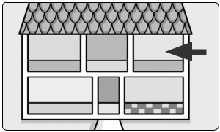
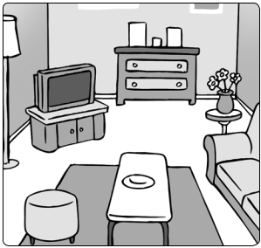
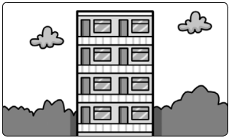

Family and Friends Special Edition Grade 3 | 53 | © Oxford University Press
Assessment and Resource Portfolio Unit 8 | 53 | Permission granted to reproduce for instructional use.

^{TOEFL} Reading

Primary

- Read and guess. What is it? Circle A, B, or C.

Example There’s a TV in this room.

What is it?


  - It’s a living room.

  - It’s a bathroom.

  - It’s an apartment.

- I sleep and play in this room with my brother. Where am I?

  - I’m in the bedroom.

  - I’m in the bathroom.

  - I’m in the kitchen.

- I can see a table and six chairs. Where am I?

  - I’m in the bedroom.

  - I’m in the bathroom.

  - I’m in the dining room.

- There are three bedrooms upstairs and a big kitchen downstairs. What is it?

  - It’s a bathroom.

  - It’s an apartment.

  - It’s a house.

Family and Friends Special Edition Grade 3 | 54 | © Oxford University Press
Assessment and Resource Portfolio Unit 8 | 54 | Permission granted to reproduce for instructional use.

^{TOEFL} Reading

Primary

- Read and answer the questions. Circle A, B, or C.
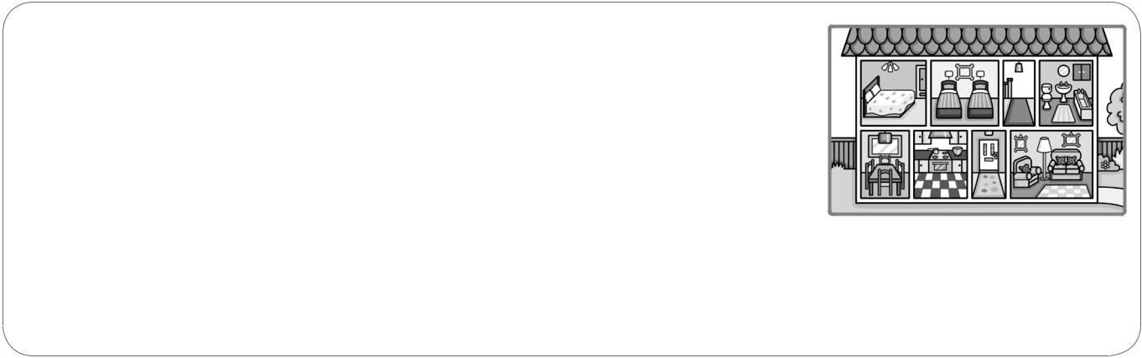

Hello! My name is Trung. This is my house. I live in this house with my mom, dad and my little sister, Trang. There are two bedrooms and a bathroom upstairs. I sleep with my sister in the little bedroom and the big bedroom is for my mom and dad.

Downstairs, there is a living room, a kitchen and a dining room.

Example What is the boy’s name?

  - Trang

  - Trung

  - Tom

- How many people live in the house?

  - Three people live in the house.

  - Four people live in the house.

  - Five people live in the house.

- How many bedrooms are there in his house?

  - There are two bedrooms.

  - There are four bedrooms.

  - There is one bedroom.

- How many rooms are there downstairs?

  - There are four rooms downstairs.

  - There are three rooms downstairs.

  - There are six rooms downstairs.

Family and Friends Special Edition Grade 3 | 55 | © Oxford University Press
Assessment and Resource Portfolio Unit 8 | 55 | Permission granted to reproduce for instructional use.


Worksheet 8 Extra writing

- Write.

ment stairs |  |  |  | chen | room |  |  | stairs room
1 apart ment |  |  |  | 2 | bed |  |  | 3 |  | kit
4 up |  |  |  | 5 | bath |  |  | 6 |  | down
2 Look and write. |  |  |  | is are isn’t |  |  |  | aren’t
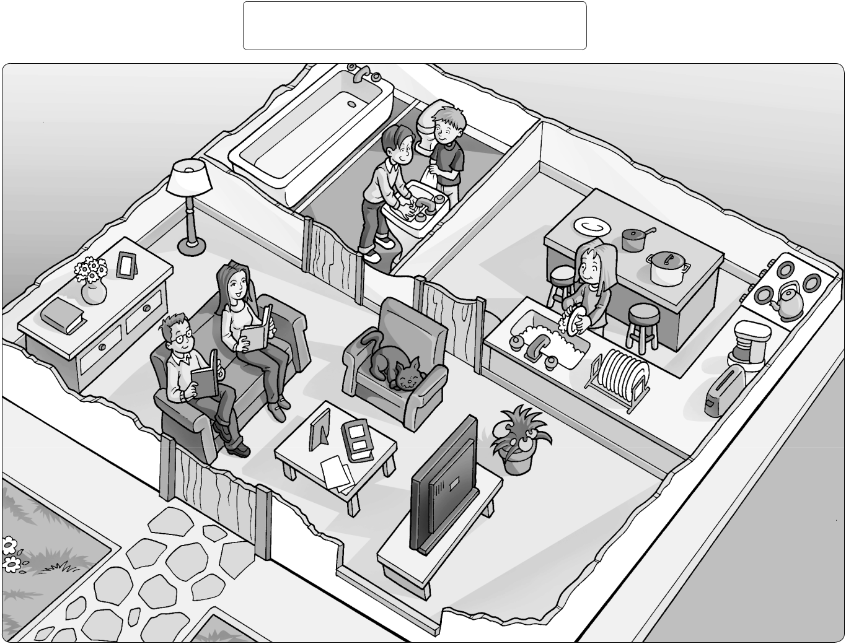

1 | Is Tessa in the kitchen? Yes, she |  |  | is .
2
2 |  | Mom and Dad in the bathroom? No, they |  |  |  |  |  |  |  |  | .
3 |  | Jack and Bob in the bathroom? Yes, they |  |  |  |  |  |  |  | .
4 |  | the cat in the kitchen? No, it |  | .
5
5 |  | Mom and Dad in the living room? Yes, they |  |  |  |  |  |  |  |  |  | .

Family and Friends Special Edition Grade 3 | 56 | © Oxford University Press
Assessment and Resource Portfolio Unit 8 | 56 | Permission granted to reproduce for instructional use.


_{Worksheet} 8 Values

My house

- Find and circle the dangers.
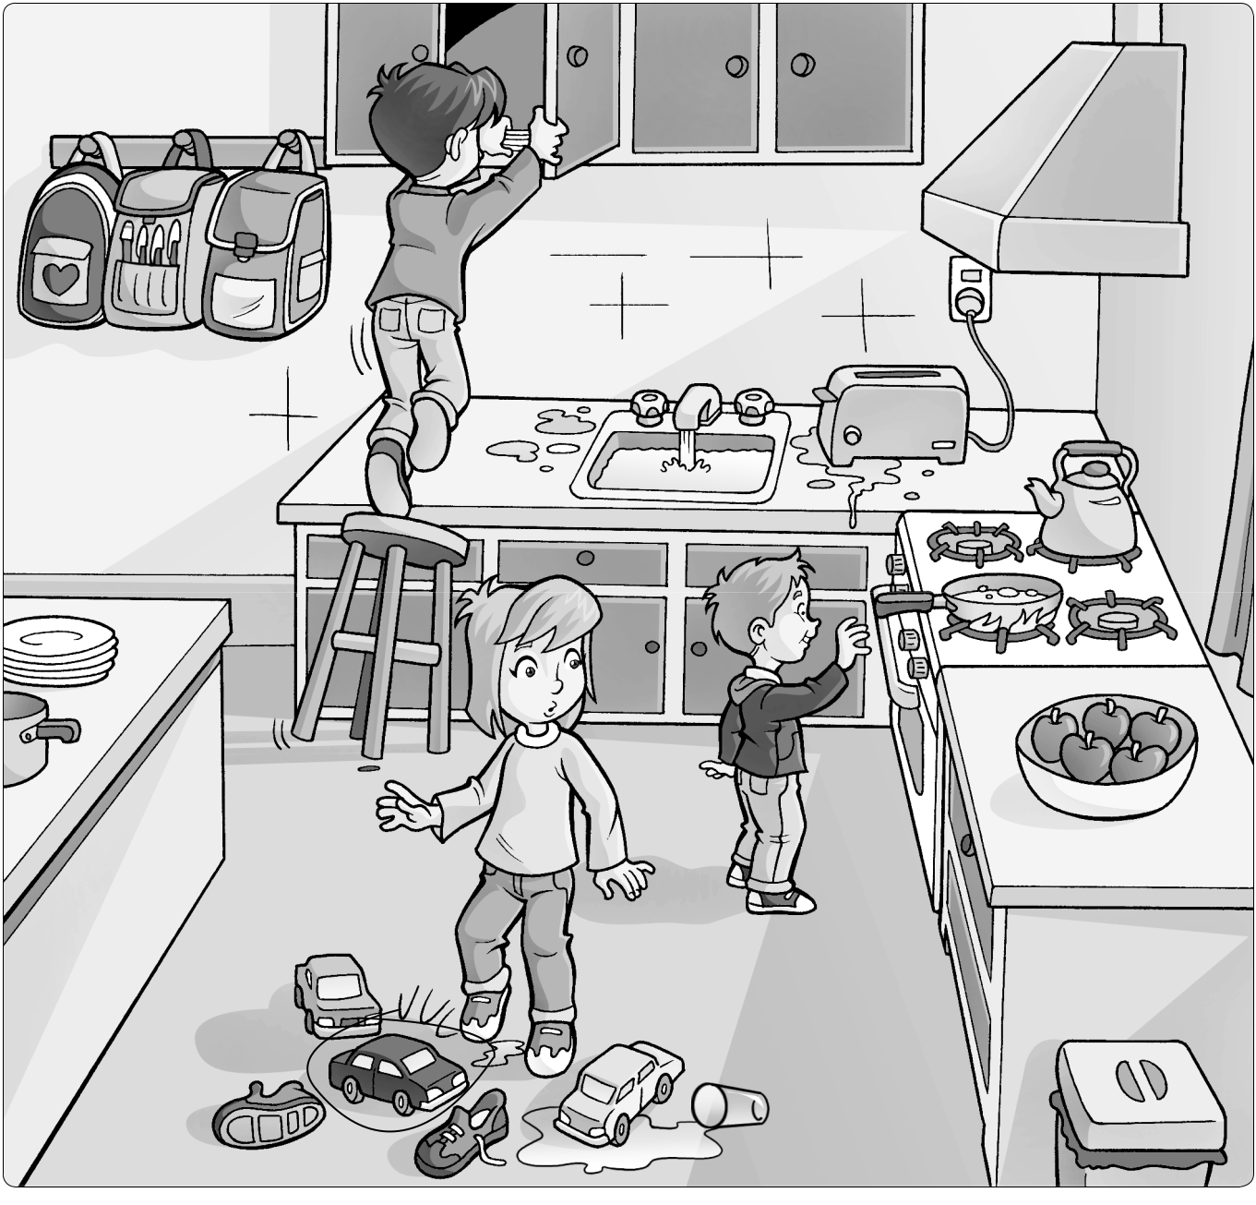

- Find and count.
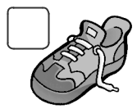



1 | 2 | 3
 | two
4 | 5

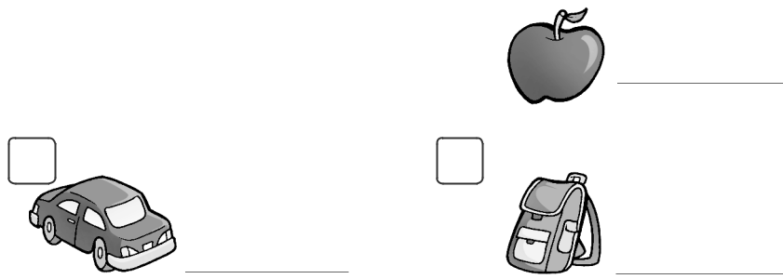

Family and Friends Special Edition Grade 3 | 57 | © Oxford University Press
Assessment and Resource Portfolio Unit 8 | 57 | Permission granted to reproduce for instructional use.


Test 8 Unit test

1 Write ✔ (yes) or ✘ (no). | / 3
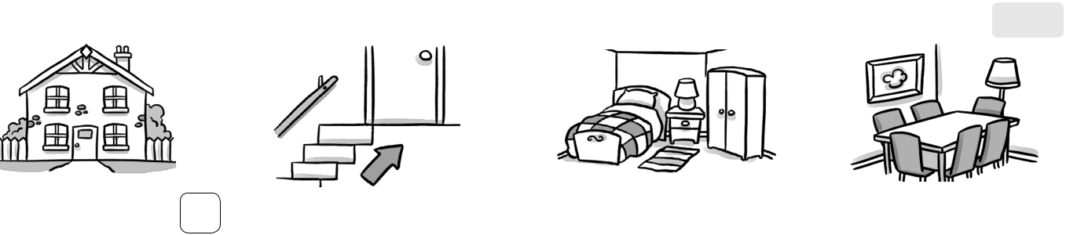

1 apartment ✘ 2 upstairs  3 bedroom 4 bathroom

2 Write the words. |  | / 4
1 h s o u e | house |  | 2 r o o m t h b a
3 c h e k i t n |  |  | 4 n i n d i g m o o r


- i v l i g n o m r o

3 | Circle the correct words. | / 4

- Where’s / Where are Rosy and Tim? 2 Where’s / Where are Grandpa?

3 Where’s / Where are Billy? 4 Where’s / Where are my cousins?

- Where’s / Where are my mom and dad?

4 Complete the sentences. | / 4

- Is Mia in the kitchen? Yes, she is .

- Are Mom and Dad in the living room?
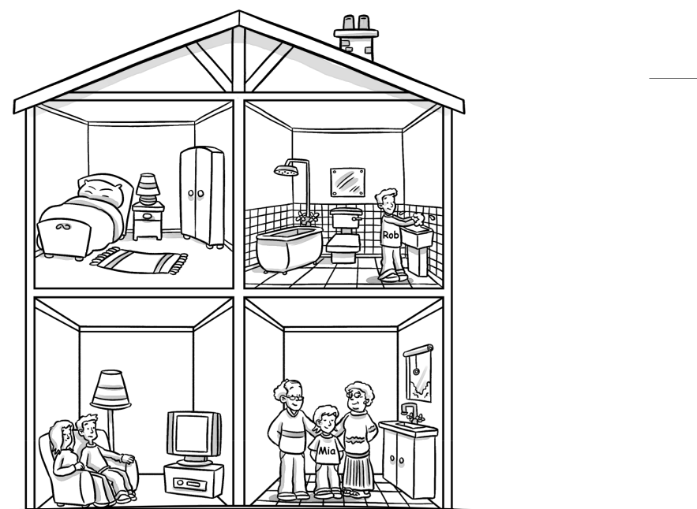

, they .

- Is Mia upstairs?

, she .

- Rob in the bathroom?

, he .

- Grandpa and Grandma in the living room?

, they .

/15


Family and Friends Special Edition Grade 3 | 58 | © Oxford University Press
Assessment and Resource Portfolio Unit 8 | 58 | Permission granted to reproduce for instructional use.

