
TOEFL 8 Reading
Primary

- Read the recipe and choose the correct answer. Circle A, B, or C.
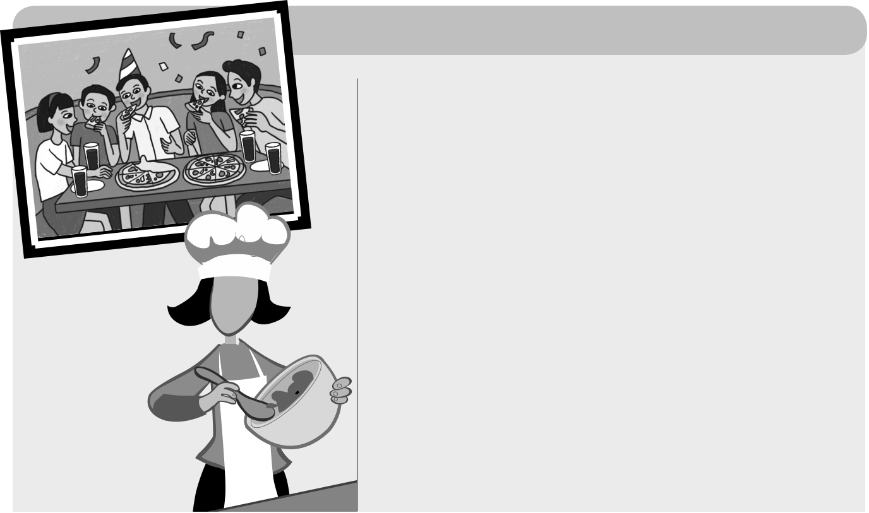

How to make tropical pizza

You need:  pizza pastry tomato sauce  pineapple  chicken  cheese

salt and pepper


- You take the pizza pastry and make it into a big circle.

- You take some tomato sauce and put it on the pizza pastry.

- You put some salt and pepper on the pizza.

❹ You take some cheese and put it on the pizza. ❺ You take some pineapple and some chicken.

You cut them small.

❻ You put the pineapple and the meat on the pizza.

❼ You cook the pizza for 10 minutes.

Would you like a different pizza? You can use onions, meat or seafood.

Example A It’s a pastry recipe.


- It’s a pizza recipe.

  - It’s a cheese and tomato recipe.

1 AYou put the tomato sauce on the pizza pastry.

BYou cut the tomatoes.

CYou put the pizza pastry on the tomato sauce.

- AThe chicken is in small pieces.

BThe chicken is in big pieces.

CThe pineapple is in big pieces.

- AYou can’t make pizza with meat.

BYou can’t make pizza with onions.

CYou can make pizza with seafood.


Family and Friends Special Edition Grade 5 | 53 | © Oxford University Press
Assessment and Resource Portfolio Unit 8 | 53 | Permission granted to reproduce for instructional use.

^{TOEFL} Reading

Primary

2



Read the conversation and answer the questions. Circle A, B, or C.

Lam <  Lam

<

Hi mom! Are you at the  supermarket?

Hi Lam. Yes, I am. I’m shopping

with Huy. I’m buying some

food for dinner.

Are you buying some chicken? I want to make my favorite dish.

Yes, I am. What do you want to make? Would you like some noodles? 

No, thank you. But I’d like some bean sprouts, please. I  want to make spring rolls.

OK. I love spring rolls, too. I can make some soup. We can have soup and spring rolls for dinner.

Good idea. I’d like vegetable soup, please.

OK. I can get some

cabbage and some onions.

Great. Thank you mom!

See you later.

See you in about 30 minutes.

Example Who is sending the messages?

- Lam’s mom and Huy are sending messages.

BLam and Huy are sending messages.

CLam and his mom are sending messages.

- What is Lam’s mom doing?

AShe’s shopping at the supermarket.

BShe’s shopping at the shopping mall.

CShe’s buying some noodles.

- What does Lam want to make?

AHe wants to make vegetable soup.

BHe wants to make spring rolls.

CHe wants to make noodles.

- What does Lam’s mom buy?

AShe buys chicken, noodles and bean sprouts.

BShe buys soup, cabbage and onions.

CShe buys chicken, bean sprouts, cabbage and onions.

Family and Friends Special Edition Grade 5 | 54 | © Oxford University Press
Assessment and Resource Portfolio Unit 8 | 54 | Permission granted to reproduce for instructional use.

^{TOEFL} Reading

Primary

- Read the advertisement for The Corner Café and answer the questions. Circle A, B, or C.

WELCOME TO THE CORNER CAFÉ!

Tired from shopping at the shopping mall? Would you like a drink now?

You can come to our café! We have coffee, tea and juice. You can have some food, too. We have sandwiches and pizzas. We also have cakes and cookies.
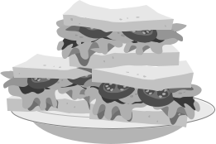

Do you want to sit and talk to your friends and family?

Come to our café! We have lots of big tables. You can sit with your family and friends. You can sit outside near the park. You can watch the children playing and having fun in the park. On a rainy day, you can sit inside.

Do you like reading?


Come to our café! We have a big collection of comics and books for children and for moms and dads. We have many comics and books in English. And we have newspapers, too! You can read and relax at the café.
We are open every day, Monday to Sunday, from 10am to 8pm.

See you soon!

Example What is this place?

- It’s a café.

BIt’s a park.

CIt’s a shopping mall.

- Can you eat and drink at the café?

AYes, you can eat and drink at the café.

BYou can drink at the café. But you can’t eat there.

CNo, but you can watch the children at the park.

- I want to go to the café with my family. The children want to play in the park. Is it a good café for me?
AYes, it is. You can sit inside and read comics.

BYes, it is. You can sit outside and watch the children in the park.

CNo, it isn’t. The tables are small in the café.

Family and Friends Special Edition Grade 5 | 55 | © Oxford University Press
Assessment and Resource Portfolio Unit 8 | 55 | Permission granted to reproduce for instructional use.

^{TOEFL} Reading

Primary

- I want to read in English. Can I do that at the café?

ANo, you can’t. There aren’t any books or comics in English at the café.

BNo, you can’t. You’re not allowed to read in the café.

CYes, you can. You can read comics and books in English at the café.

- What is this text?

AIt’s an advertisement for a café.

BIt’s a news report.

CIt’s a story.

Family and Friends Special Edition Grade 5 | 56 | © Oxford University Press
Assessment and Resource Portfolio Unit 8 | 56 | Permission granted to reproduce for instructional use.


Worksheet 8 Extra writing

- Complete the puzzle.


Across |  |  |  | 1 | p e | a | 2 | s | Down
1 |  | 6 | 7 | 9 | p e | a |  | s | 2
10 |  |  |  | 3 _{c} |  |  |  |  | 3
11 |  | ⁴ p | ⁵ b | 6 _{m} |  |  |  |  | 4
11 |  |  | 7 _{c} |  |  |  |  |  | 4
11 |  |  | 7 _{c} | 9 _{l} |  |  |  |  | 8_{o}
 |  |  |  |  |  |  |  |  | 5
 |  |  |  | 10_{p} |  |  |  |  | 6
 | 11 | c |  |  |  |  |  |  | 6

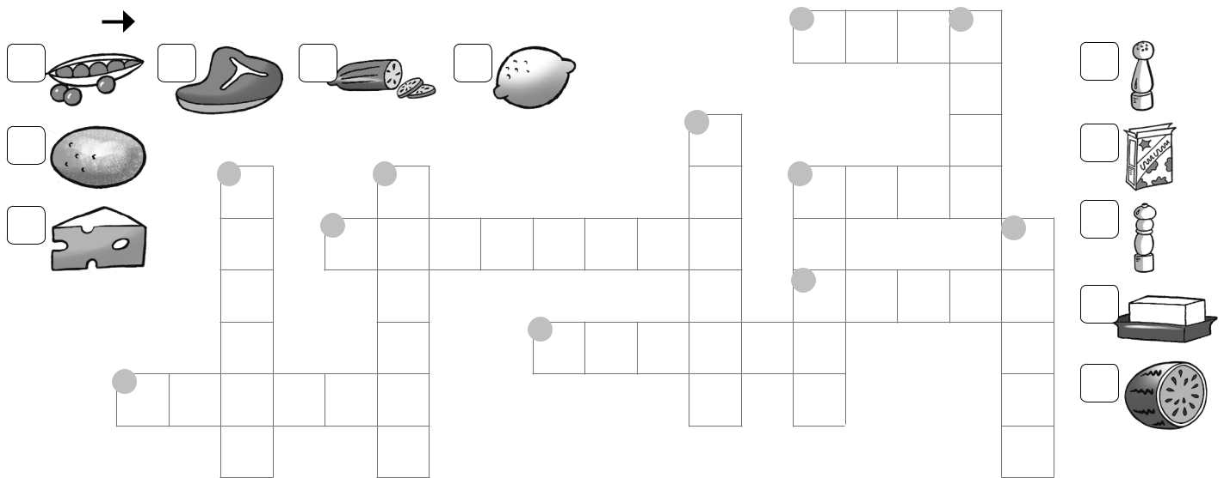

8 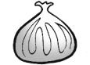


- Read and write ✓ or . Correct the mistakes.


- Would you like an orange?

- He’d like a egg.

- I’d like some water.

- They’d like a cheese.

- Would she like any cookie?

- We’d like some apples, please.

- I’d like a rice.

- She’d like a bread.

What’s your favorite food? Write a sentence and draw.

✓

- an egg


Family and Friends Special Edition Grade 5 | 57 | © Oxford University Press
Assessment and Resource Portfolio Unit 8 | 57 | Permission granted to reproduce for instructional use.


Test 8 Unit test


1 Check () the foods you see. Then write the words. | /4
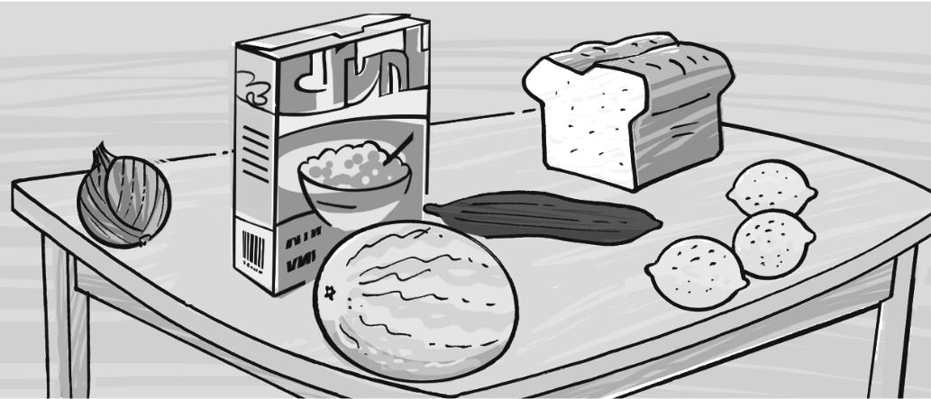

pastries |  |  |  | sauce |  |  | bread |  |  |  |  |  |  |  | 1 | br e |  |  |  |  |  |  |  | a d
 |  |  |  |  |  |  |  |  |  |  |  |  |  |  | 2 c |  |  |  | r e |  |  |  |  |  |  | l
cereal |  |  |  | lemon |  |  | cheese
 |  |  |  |  |  |  |  |  |  |  |  |  |  |  | 3 | m |  |  |  | l |  |  |  |  | n
melon |  |  |  | garlic |  |  | cucumber |  |  |  |  |  |  |  | 3
 |  |  |  |  |  |  |  |  |  |  |  |  |  |  | 4 l |  |  |  |  |  |  |  | on
mushrooms |  |  |  | juice |  |  | onion
 |  |  |  |  |  |  |  |  |  |  |  |  |  |  | 5 | c |  |  | c |  |  |  |  | mber
2 Write a, an, or some. |  |  |  |  |  |  |  |  |  |  |  |  |  |  |  |  |  |  |  |  |  |  |  | /7
1 some pasta |  |  |  | 2 |  |  |  | onion |  | 3 |  |  |  |  |  |  |  |  | mushroom
4 |  |  | cereal | 5 |  |  |  | lemon |  | 6 |  |  |  |  |  |  |  |  | sauce
7 |  |  | egg | 8 |  |  |  | onions
3 Complete. |  |  |  |  |  |  |  |  |  |  |  |  |  |  |  |  |  |  |  |  |  |  |  | /4
’d like |  | Yes, please |  | Would you |  | No, thanks |  |  |  | would like
 |  |  |  | Amy |  | Hello. 1 I ’d like some fruit, please.
 |  |  |  |  |  |  |  |  |  |  |  |  |  |  |  |  |  |  |  |  |  |  |  |  |  |  | like
 |  |  |  | Sales clerk |  | We have some nice fruit. 2 |  |  |  |  |  |  |  |  |  |  |  |  |  |  |  |  |  |  |  |  | like
 |  |  |  | Amy |  | an apple? |  |  |  |  | . I don’t like apples.
 |  |  |  |  |  | 3
 |  |  |  | Sales clerk |  | Well, I’m sure your brother
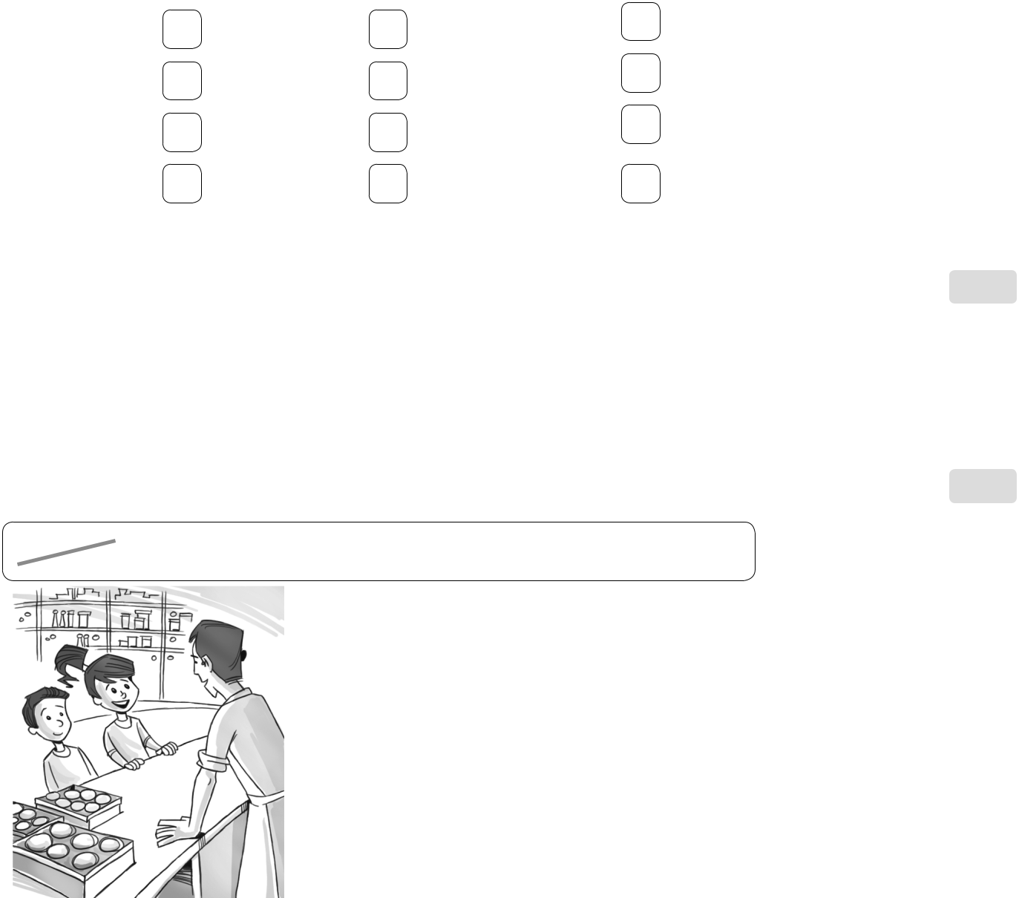

Fred

4

5

one of these oranges.


! /15

Family and Friends Special Edition Grade 5 | 58 | © Oxford University Press
Assessment and Resource Portfolio Unit 8 | 58 | Permission granted to reproduce for instructional use.

