**School : ___________________ Primary school Test**

**Name : _____________________ Subject : English**

**Class : 2/_ Date : _______________**

|  |  |
| --- | --- |
| **Marks** | **Remark** |

**I.Listening.**

**Part 1. Listen and choose the correct answer.** (Nghe và chọn câu đúng) (2 points)

|  |  |  |  |
| --- | --- | --- | --- |
| 0. | A. It’s raining. | B. It’s snowing. | C. It’s sunny. |
| 1. | A. I’m wet. | B. I’m hot. | C. I’m cold. |
| 2. | A. I’m hungry. | B. I’m sad. | C. I’m happy. |
| 3. | A. Noodles. | B. Soup. | C. Chicken. |
| 4. | A. That’s my pillow. | B. That’s my bear. | C. That’s my blanket. |
| 5. | A. Bear. | B. Pillow. | C. Blanket. |
| 6. | A. Red light. Stop! | B. Green light. Go! | C. Yellow light. Go slow! |
| 7. | A. He’s a farmer. | B. She’s a doctor. | C. She’s a police officer. |
| 8. | A. Ice cream. | B. Candy. | C. Chips. |

**Part 2. Listen and write.** (Nghe và viết từ đúng vào chỗ trống) (0,5 point)

|  |  |  |
| --- | --- | --- |
| raining | hungry | Be quiet! |

|  |  |
| --- | --- |
| 0. | I’m hungry . Have some chicken. Mmm. It’s good. |
| 1. | Hurry up! It’s . I’m wet. |
| 2. | That’s my pillow. No! It’s my pillow. Shh! . |

**II. Choose the word with the correct spelling.** (Chọn từ đúng chính tả) (2 points)

|  |  |  |  |  |  |
| --- | --- | --- | --- | --- | --- |
| 0. |  | Dotor  Doctor  Docton |  |  |  |
| 1. | Chicken  Chiken  Chickel |  |  | 2. | Pillou  Pillow  Pilow |
|  | 3. | Chipp  Ships  Chips | 4. | Baer  Bear  Brear |  |
| 5. | Blanket  Banket  Blamket |  |  | 6. | Codl  Cool  Cold |
|  | 7. | Snowimg  Snoving  Snowing | 8. | Suop  Soup  Soap |  |

**III. Odd one out.** (Tìm từ khác loại) (2 points)

|  |  |  |  |
| --- | --- | --- | --- |
| A | B | C | D |
| 0. chicken | soup | blanket | noodles |
| 1.hot | pillow | cold | wet |
| 2.pillow | soup | bear | blanket |
| 3.raining | sunny | snowing | chicken |
| 4.red light | bear | green light | yellow light |
| 5.farmer | doctor | candy | police officer |
| 6.candy | police officer | ice cream | chips |
| 7.pillow | bear | blanket | wet |
| 8.teacher | chips | doctor | farmer |

**IV. Complete.** (Hoàn thành mỗi từ sau bằng cách thêm 1 chữ cái) (1,5 points)

|  |  |  |  |  |  |
| --- | --- | --- | --- | --- | --- |
| 0. |  | ra i ning | 4. |  | w t |
| 1. |  | h t | 5. |  | no dles |
| 2. |  | ca dy | 6. |  | po ice officer |
| 3. |  | s nny | 7. |  | ic cream |

**V. Read and choose the correct response.** (Đọc và chọn câu phản hồi đúng) (2 points)

|  |  |  |  |
| --- | --- | --- | --- |
| 0.Hurry up! | =>A.I’m wet. | B.It’s raining. | C.It’s sunny. |
| 1.I’m hungry | =>A.I’m hot. | B.I’m cold. | C.Have some chicken. |
| 2.That’s my pillow | =>A.Go! | B.No, It’s my pillow. | C.It’s sunny. |
| 3.Hurry up! It’s raining | =>A.I’m wet. | B.No! not today. | C.Go! |
| 4.Red light. | =>A.Go! | B.I’m cold. | C.Stop! |
| 5.I want candy. | =>A.No! not today. | B. No, It’s my bear. | C. No, It’s my blanket. |
| 6.Green light. | =>A.It’s snowing. | B.Go! | C.I’m cold. |
| 7.I’m hungry.Have some chicken. | =>A.Mmm.It’s bad | B. No! not today. | C. Mmm.It’s good. |
| 8.That’s my bear. No, It’s my bear. | =>A.Shh! Be quiet! | B.Stop! | C.Go! |

**THE END**

**School : ___________________ Primary school Test**

**Name : _____________________ Subject : English**

**Class : 2/_ Date : _______________**

|  |  |
| --- | --- |
| **Marks** | **Remark** |

**I. Complete the sentences : ( 3 points )**

1. She’s a……………………… 2. She’s a………………………



1. He’s a……………………… 4. She’s a………………………



5. I’m hungry. 6. I’m hungry.

Have some……………… Have some………………



Mmm. It’s good. Mmm. It’s good.

**II. Uncramble and match : ( 2 points )**

ebar **……………………**

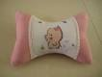

spou ……………………

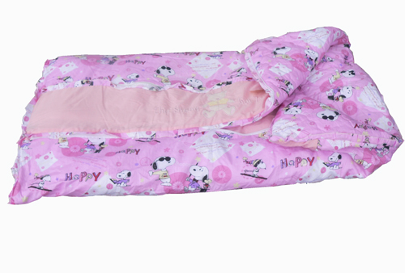

llowpi ……………………

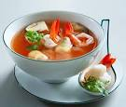

ketblan …………………..

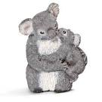

**III. Match : ( 3 points )**

sunny



raining



snowing



wet



cold



hot



**VI. Look and write (2 points)**

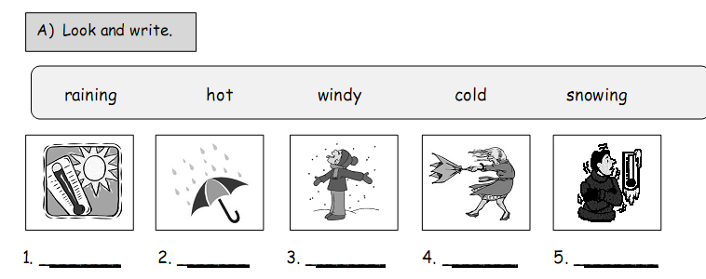

THE END

**School : ……………………….. Primary school Test**

**Name : _____________________ Subject : English**

**Class : 2/_ Date : _______________**

|  |  |
| --- | --- |
| **Marks** | **Remark** |

**I, Khoanh tròn các từ phù hợp với tranh(2 điểm).**

**4.**

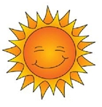

**sunny**

**snowing**

**raining**

**1.**

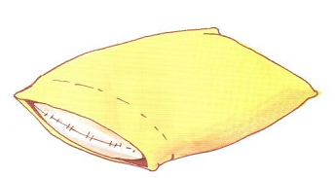

**pillow**

**blanket**

**bear**

**2 .**

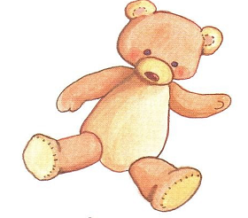

**mouse**

**monkey**

**bear**

**3.**

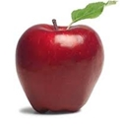

**apple**

**mango**

**orange**

**II,** **Dịch sang Tiếng Anh (2,5 điểm).**

1. Mình muốn kẹo. ……………………………………………
2. Cô ấy là một cảnh sát. ……………………………………………
3. Ông ấy là một nông dân. ……………………………………………
4. Mình thì đói bụng. …………………………………………….
5. Đó là cái gối của mình. ……………………………………………

**III, Điền chữ còn thiếu vào mỗi từ sau (1,5 điểm).**

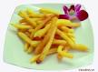

1. **r.…….**  **2. ch…. . 3.s………**



**4.c.……….**  **5. s…. … 6. h………..**

**IV. Sắp xếp lại các chữ cái để tạo được từ phù hợp với mỗi tranh sau(4 điểm).**



**1. faerrm-> .................................... 2. hcretea->..........................................**



**3. noodesl->........................................ 4. balnetk -> .......................................**



**5. llopiw->........................................ 6. supo -> .......................................**



**7. polci officre->..................................... 8. tordoc-> .......................................**

“ Good luck to you ”

“ the end ”